Vocabulary terms for definition textbox

Hexokinase

a-D-Glucose + ATP à Glucose-6-phosphate (G6P) + ADP

The first step in glycolysis where a phosphate group is added to glucose using ATP.  This reaction is important for its ability to trap glucose within the cell. Whereas glucose can easily traverse the plasma membrane, the negatively charged phosphate group prevents G6P from crossing, so cells can stock up on glucose while levels are high.  This reaction is highly regulated, with G6P providing a feedback inhibition of the enzyme, thereby preventing excessive stockpiling until glycolysis depletes G6P levels.

Phosphoglucose Isomerase

Glucose-6-phosphate (G6P) à Fructose-6-phosphate (F6P)

Phosphoglucose isomerase (PGI) is the second step in glycolysis that catalyzes the interconversion of G6P and F6P during glycolysis and gluconeogenesis.  The shift of the carbonyl oxygen from the C1 position in G6P to the C2 position in F6P is necessary in order to add another phosphate group at the C1 position in a later reaction. This is a multi-functional enzyme that moonlights as neuroleukin.

Phosphofructokinase

Fructose-6-phosphate (F6P) + ATP à Fructose-1,6-bisphosphate (F1,6PP) + ADP

The third step in glycolysis is another priming reaction, adding a second phosphate group to F6P. This reaction is unidirectional, committing the cell to glycolysis, as opposed to energy storage, or producing a different sugar.  A different enzyme, fructose bisphosphatase, is required to catalyze the reverse reaction.  The cellular levels of phosphofructokinase (PFK) and fructose bisphosphatase help drive metabolism towards glycolysis or gluconeogenesis, respectively.

Fructose-bisphosphate Aldolase

Fructose-1,6-bisphosphate (F1,6PP) à dihydroxyacetone phosphate (DHAP) + Glyceraldehyde-3-phosphat

This enzyme is the fourth step in glycolysis that catalyzes the reversible cleavage of F1,6PP to two triose phosphates, both of which continue through glycolysis. There are two classes of aldolases, which have different catalytic mechanisms: class I enzymes are found in animals, do not require a metal ion, and are characterized by the formation of a Schiff base intermediate between an active site lysine and a substrate carbonyl group, while the class II enzymes are produced in bacteria and fungi, and require an active-site divalent metal ion.  Isozymes are found for each class of enzyme, and in vertebrates the genes encoding each isozyme show tissue-specific expression.

Triosephosphate isomerase

Dihydroxyacetone phosphate (DHAP) à Glyceraldehyde-3-phosphate (G3P)

The fifth step in glycolysis, Triosephosphate isomerase (TIM) catalyzes the reversible interconversion of G3P and DHAP.  Only G3P can be used in glycolysis, therefore TIM is essential for energy production, allowing two molecules of G3P to be produced for every glucose molecule, thereby doubling the energy yield.

Glyceraldehyde 3-phosphate Dehydrogenase

Glyceraldehyde-3-phosphate (G3P) +NAD+ + Pi à 1,3-Bisphosphoglycerate (1,3BPG) + NADH + H+

Glyceraldehyde-3-phosphate dehydrogenase (GAPDH) is in the second phase of glycolysis, plays an important role in glycolysis and gluconeogenesis by reversibly catalyzing the oxidation and phosphorylation of G3P to the energy-rich intermediate 1,3BPG.  NAD+ is a co-substrate for this reaction. GAPDH displays diverse non-glycolytic functions as well, its role depending upon its subcellular location.  For instance, the translocation of GAPDH to the nucleus acts as a signaling mechanism for programmed cell death, or apoptosis.  The accumulation of GAPDH within the nucleus is involved in the induction of apoptosis, where GAPDH functions in the activation of transcription.  The presence of GAPDH is associated with the synthesis of pro-apoptotic proteins like BAX, c-JUN and GAPDH itself.

Phosphoglycerate Kinase

 1,3-Bisphosphoglycerate (1,3BPG) + ADP à 3-Phosphoglycerate (3PG) + ATP

Phosphoglycerate kinase (PGK) is an enzyme that reversibly catalyzes the formation of ATP to ADP, using one of the high-energy phosphate groups from 1,3BPG.  The reaction forms two ATP molecules per glucose (one per 1,3BPG molecule), which compensates for the expenditure of 2 ATP in phase I of glycolysis.  The ATP is made by substrate-level phosphorylation, where a phosphate group is transferred from 1,3BPG directly to ADP.  This reaction is essential in most cells for the generation of ATP in aerobes, for fermentation in anaerobes and for carbon fixation in plants.

Phosphoglycerate Mutase

3-Phosphoglycerate (3PG) à 2-Phosphoglycerate (2PG)

Phosphoglycerate mutase (PGAM) catalyzes the transfer of the phosphor group from the C3 position to the C2 position, in preparation for the synthesis of ATP.  PGAM enzymes from different sources exhibit different reaction mechanisms.  For instance, some PGAM enzymes (vertebrates, fungi, certain bacteria) use 2,3-bisphophoglycerate as a cofactor to phosphorylate a serine residue to prime the reaction, whereas other PGAM enzymes (plants, certain invertebrates, algae, certain bacteria) carry out intramolecular phosphoryl group transfer via an active site residue without the need of a cofactor.

Enolase

 2-Phosphoglycerate (2PG) à Phosphoenolpyruvate (PEP) + H2O

Enolase (phosphopyruvate hydratase) is an essential glycolytic enzyme that catalyzes the reversible dehydration of 2-phosphoglycerate to the high-energy intermediate phosphoenolpyruvate.  Enolase is strongly inhibited by fluoride ions, which forms a fluorophosphate complex with magnesium at the active site.  In vertebrates, there are 3 different, tissue-specific isozymes, designated alpha, beta and gamma. Alpha is present in most tissues, beta is localised in muscle tissue, and gamma is found only in nervous tissue.

Pyruvate Kinase

Phosphoenolpyruvate (PEP) + ADP à Pyruvate + ATP

Pyruvate kinase (PK) catalyses the final step in glycolysis, the conversion of PEP to pyruvate with the concomitant transfer of the high-energy phosphate group from PEP to ADP, thereby generating ATP.  PK requires both magnesium and potassium for activity.  In vertebrates, there are four tissue-specific isozymes: L (liver), R (red cells), M1 (muscle, heart and brain), and M2 (early foetal tissue). In plants PK exists as cytoplasmic and plastid isozymes, while most bacteria and lower eukaryotes have one form, except in certain bacteria, such as *Escherichia coli*, that have two isozymes.

Information came from InterPro Website <https://www.ebi.ac.uk/interpro/potm/2004_2/Page3.htm>

ATP

Adenosine triphosphate

A complex organic chemical that provides energy to drive many processes in living cells, e.g. muscle contraction, nerve impulse propagation, and chemical synthesis. Found in all forms of life, ATP is often referred to as the "molecular unit of currency" of intracellular energy transfer.

Information came from Wikipedia <https://en.wikipedia.org/wiki/Adenosine_triphosphate>

(pictures needed?) they are all different from every website

Ask Dr. Watson what pictures or website links he would want

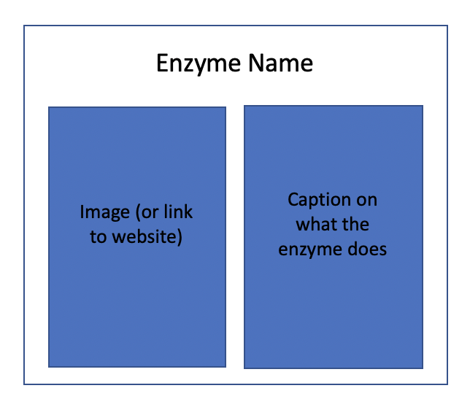 

Option 1. User double clicks on an enzyme and the definition box pops up for that particular enzyme.

Option 2. On the choose module screen there would be another screen option to for help and definitions. (easier option)

Instructions box pops up when user enters a new screen?

